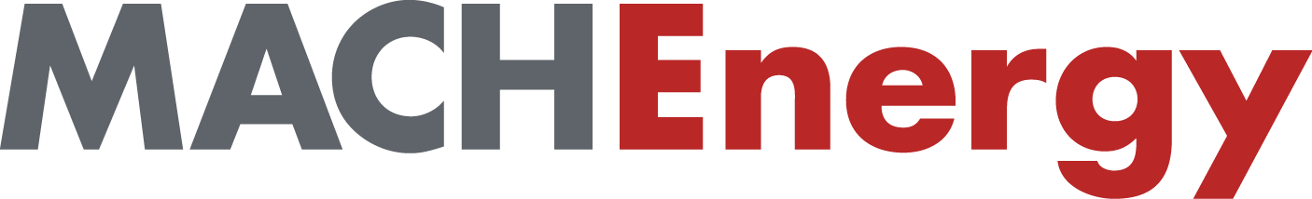

Aboriginal Community Development Fund

FUNDING GUIDELINES

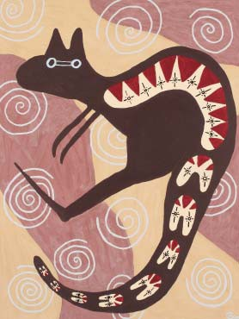

MACH Energy Australia’s contribution to the area extends beyond the immediate economic benefits of our business. We invest in the communities surrounding our operation through donations, sponsorships and partnerships to build stronger and more sustainable communities.

We are committed to ensuring our relationship with the Aboriginal people in the communities where we operate is based on mutual respect, active partnership and long term commitment. We are committed to better understanding how MACH Energy can best benefit Aboriginal communities in the Upper Hunter Valley.

The cover artwork by Denise Hedges is entitled Brother Kangaroo
and is her representation of the life blood of the Wonnarua people
of the Valley.

Introduction

The objective of the ACDF is to provide funds to community-identified and driven projects that will assist in developing the vision of the Upper Hunter Valley Aboriginal Community (UHVAC). The vision essentially seeks to achieve equivalent access and outcomes in education, training, employment and economic participation as that enjoyed by the community as a whole as well as retaining the unique heritage and traditions of the UHVAC.

This document outlines:

- How to apply for funding; and

- How projects will be assessed by the ACDF.

The ACDF has been established as a partnership programme that aims to assist projects that will deliver long-term, sustainable outcomes for the Upper Hunter Valley Aboriginal Community.

1

Applications may be made by members of the Upper Hunter Valley Aboriginal Community, who can demonstrate they have been a resident for a minimum of three years, within the geographical area including the Shires of Muswellbrook, Singleton and Upper Hunter.
Proposals

Applications may also be made by service providers, organisations or groups in the Upper Hunter Valley area, with the express purpose of providing direct benefit to the UHVAC.

Only one application per year can be made by an individual or organisation. In order to receive funding, applications must meet the following mandatory criteria:
  - Show how the project/proposal will achieve outcomes that assist the UHVAC to move towards achieving their vision for the future;
  - Outline the experience and skills of the person who will manage the project/proposal;
  - Highlight any financial or in kind support the project/ proposal has received from the applicant or other groups or government agencies and whether this support is agreed in principle, or paid and received;
  - Demonstrate measurement of progress and outcomes of the project proposal;
  - If funding is for business development opportunities, detail the benefit for the broader community, for example, the number of jobs created;

2

- If funding is for education, training or scholarships, detail how the UHVAC will benefit and highlight the potential for employment at the end of the training or scholarship;
- Detail how the project/proposal will assist to develop and strengthen relationships within the community or with MACH Energy;
- Highlight opportunities to collaborate with existing projects to create a bigger project that avoids duplication and competition; and
- Provide two written personal or business references.

In addition, applicants should attempt to address the following optional criteria in their application:
- Detail any research that has been done on the viability of the proposal, how the proposal will be implemented and expected outcomes;
- Detail how the project will be sustained once ACDF funding is finished;
- Highlight any other groups or sections of the community currently supporting the proposal; and
- Any other information that may strengthen your application and that the ACDF may find useful.

3

As a guide, eligible applicants are regarded as those who:
Application Process
  - Can demonstrate they can make effective use of the funds;
  - Are willing and able to measure the performance of the project; and
  - Can work in partnership with the Aboriginal Community Development Fund (ACDF).
Applicants cannot apply for funding of:
  - Native title matters;
  - Cultural heritage management matters;
  - Purchase of major capital items such as cars and major items of plant or equipment;
  - Permanent positions;
  - Interstate or overseas travel; or
  - Issues to be dealt with or considered by legal process.

Proposals funded by the ACDF cannot be used as supporting material in any legal process.

SUPPORTING THE VISION
Funding may be provided for projects that will assist to achieve the vision for the future. Examples are given below.

Economic Development
  - Business Development (new and existing) - Business planning, marketing plans, financial management etc
  - Training – business owners (and job seekers in specific circumstances)
  - Employment – strategies/programmes which demonstrate strong potential to create/sustain employment for Aboriginal people.

Education
  - Targeted education programmes in local schools
  - Secondary school or tertiary study assistance.

4

Health
- Targeted/innovative community health programmes and initiatives
- Grants to individuals in specific circumstances to support health and well-being
- Sporting programmes/initiatives and sponsorship of specific events
- Targeted health and well-being programmes in schools.

Community and Cultural Development
- Sponsorship of significant local events/celebrations e.g. NAIDOC Week; Reconciliation Week; Wupa@Wanaruah Art and Cultural Event
- Local programmes or projects which will deliver tangible and lasting cultural or community development benefits
- Cultural programmes in local schools.

If you have a project or concept you think is appropriate for funding, contact the Executive Officer to discuss your
idea. If it shows potential, the Executive Officer can provide assistance to prepare an application.

In completing the application form, applicants will need to explain how the project will meet the aims of the ACDF, how they will measure its success and how the project will be undertaken.

The Committee

The Committee will consider completed applications at its meetings, which are scheduled to occur at least three times per year.

5

6

For more information:

If you wish to discuss your proposal, obtain an application form or would just like more information, please contact:

The Executive Officer Aboriginal Community Development Fund
c/- MACH Energy Australia
Mount Pleasant Mine
PO Box 351
Muswellbrook 2333
Ph: 1800 886 889
Email: ngaire.baker@machenergyaustralia.com.au

